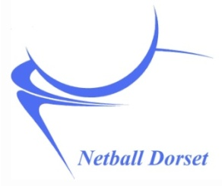
Alternative Funding Details

Netball Dorset administers the following Funds.

Each 'pot' has specific criteria and conditions attached to it, and each application is individually considered by the administrators of that fund.
Applications for funding from one of these funds can be made using the Funding form available on www.netballdorset.co.uk. Please state clearly which fund you are applying for.

EDCNA Development in Bournemouth Fund
This funding is for the benefit and development of Bournemouth Netball Association members and facilities - from East Dorset County Netball Association - winding up ring-fenced funds.
EDJNL Development in Juniors Fund
This funding is to be used for the development of juniors and students from Dorset either in the athlete performance pathway, officiating or coaching - from EDJNL winding up funds
Denise Camp Fund
This funding is for aspiring coaches in North and West Dorset - from Dorset Playing Fields Association
DSNA Fund
This funding is for schools competitions in Dorset - from Dorset Schools Netball Association
There is also funding available from these External Funding Websites:
- www.sportengland.org/funding.aspx
- www.activedorset.org/Funding
- www.stevebernardfoundation.org
- www.dorsetcommunityfoundation.org/apply-for-a-grant/comic-relief/
- www.dorsetforyou.com/387525 (Christchurch and Purbeck District Council)
- www.dorsetforyou.gov.uk/article/387535 (West Dorset District Council)
- www.dorsetforyou.gov.uk/article/420092 (East Dorset District Council)

